Ayushman Bharat: A Comprehensive Approach to Health

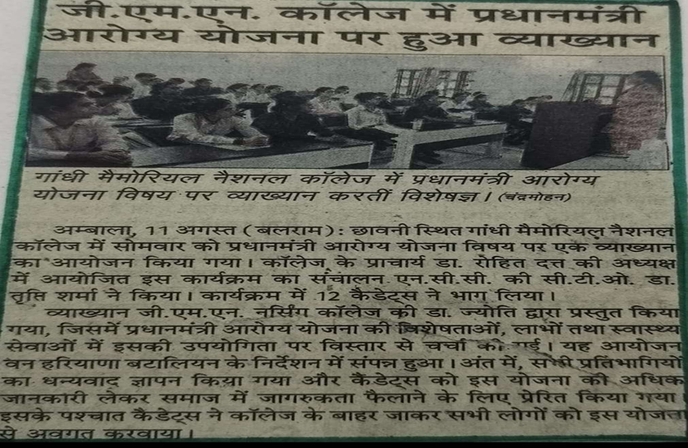

An awareness program on Ayushman Bharat Yojna (PM-JAY) was organized by GMN College of Nursing in collaboration with NCC candidates under the valuable guidance of Dr. Rohit Dutt, Principal The session was conducted by Mrs. Jyoti Kumari, who highlighted the objectives, benefits, and implementation strategies of the scheme.
The program aimed at sensitizing students and the community about the significance of this flagship health insurance scheme launched by the Government of India to provide accessible and affordable healthcare services to economically weaker sections of society. NCC cadets actively participated by interacting with the audience, distributing pamphlets, and sharing informative messages on preventive healthcare, insurance benefits, and hospital empanelment under PM-JAY.

